**Trunking Configuration Between Two Switches**

**Network Overview:**

The configuration consists of two Cisco 2960-24TT switches interconnected via a trunk link, with each switch connecting two end-user PCs. This setup enables inter-switch communication and VLAN traffic flow

**Hardware Components:**

* 2 x Cisco Catalyst 2960-24TT Switches
* 4 x PC workstations (PC0, PC1, PC2, PC3)
* Ethernet cables for connectivity

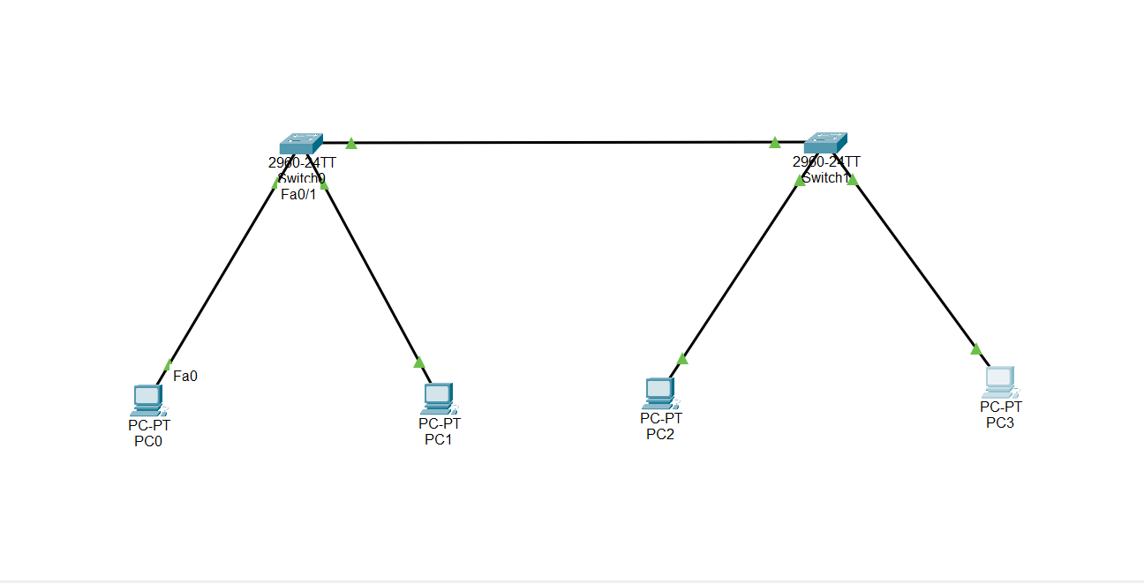

**PC IP Configuration**

**On pc 0**

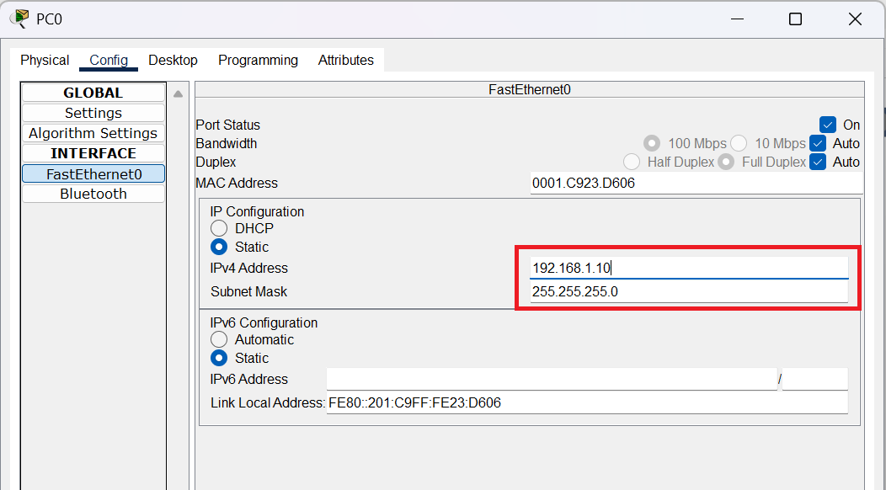

**On pc 1**

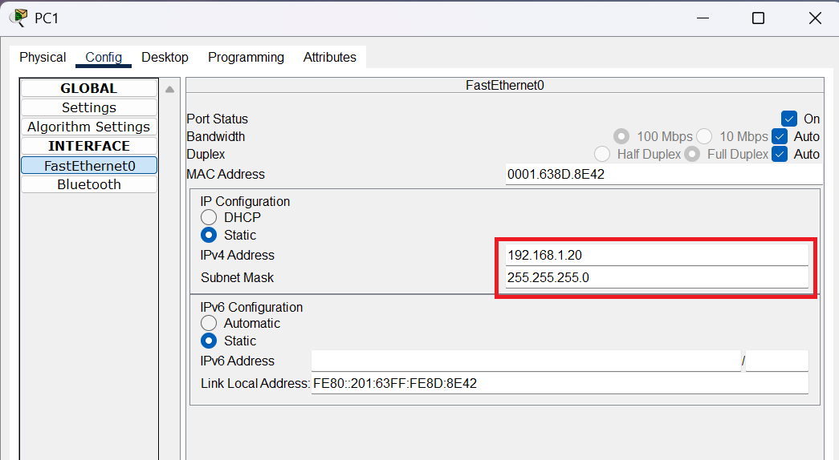

**On pc 2**

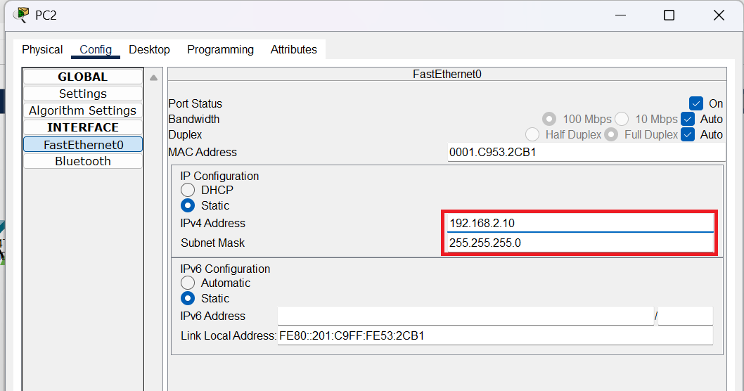

**On pc 3**

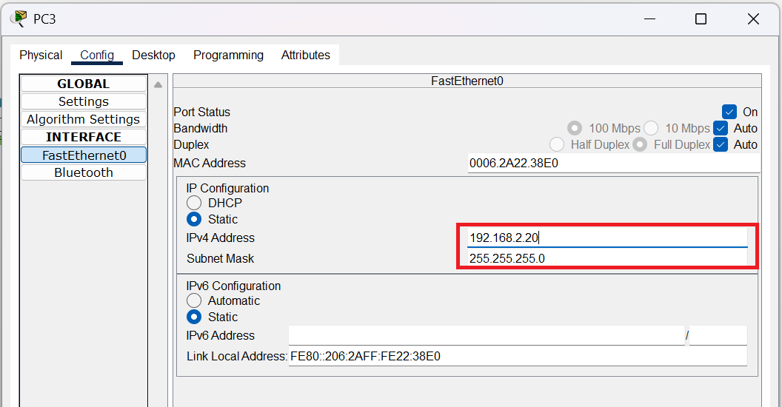

**VLAN Creation and Configuration**

**On Switch 0**

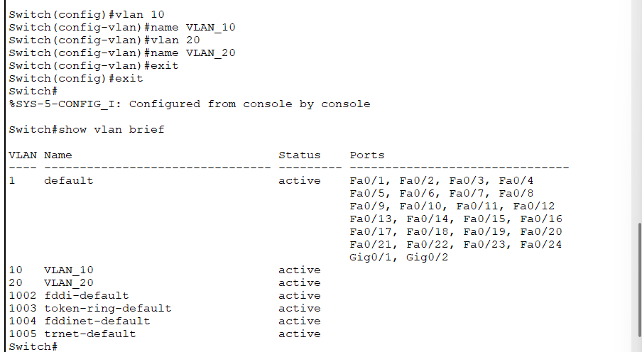

**On Switch 1**

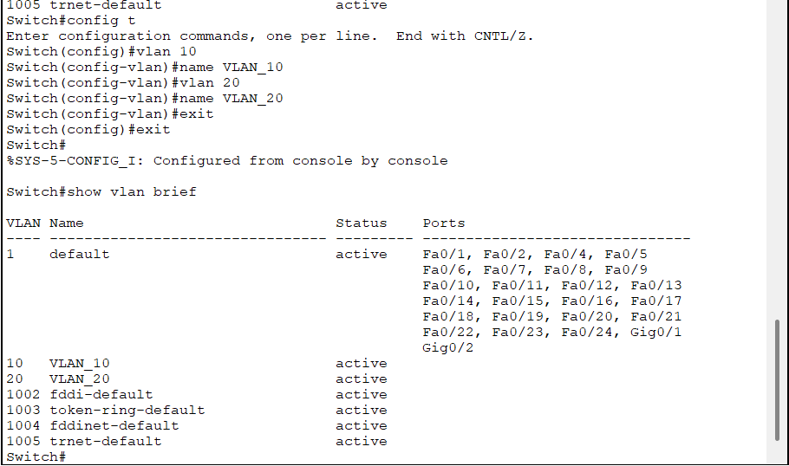

**Configuring FastEthernet interfaces (0/1 and 0/2)**

**Switch 0**

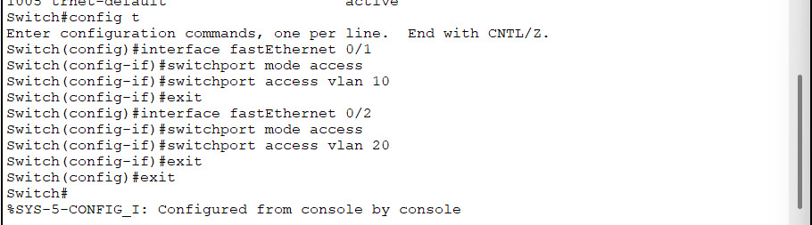

**Switch 1**

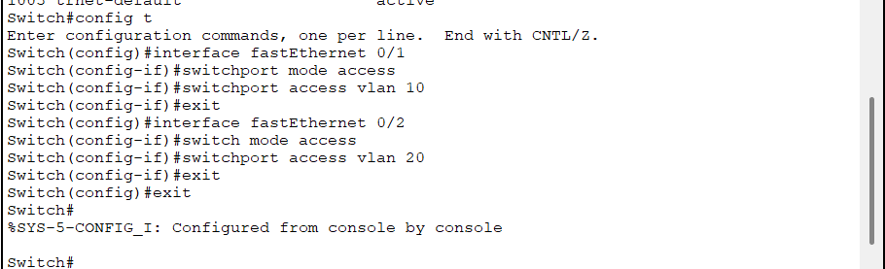

**Setting up trunk mode**

**Switch 0**

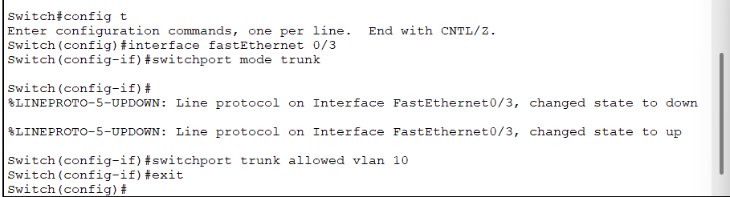

**Switch 1**

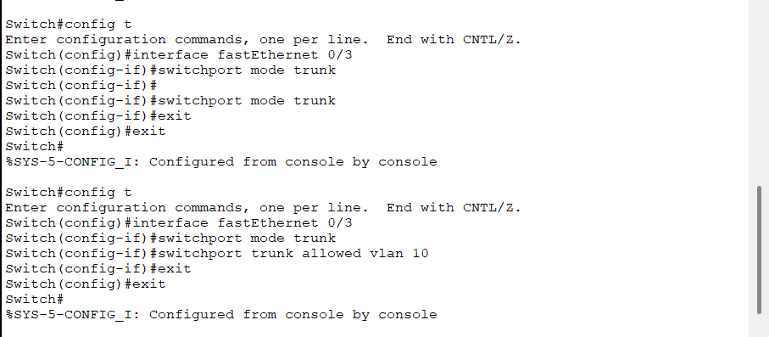

**Verification Commands**

**Switch 0**

Show vlan brief

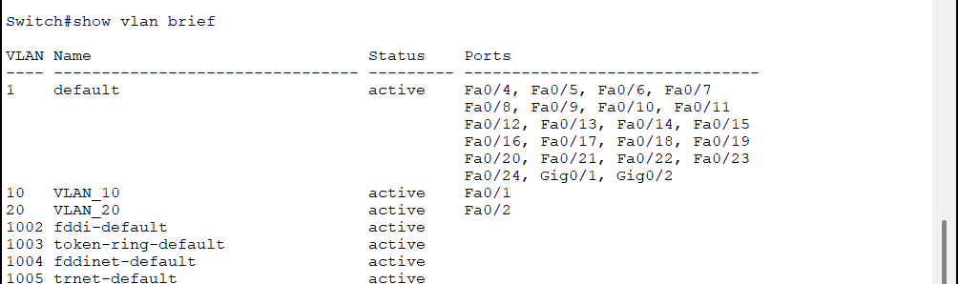

Show interfaces trunk

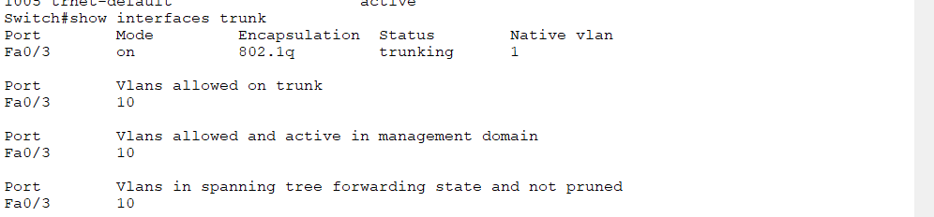

Show interfaces status

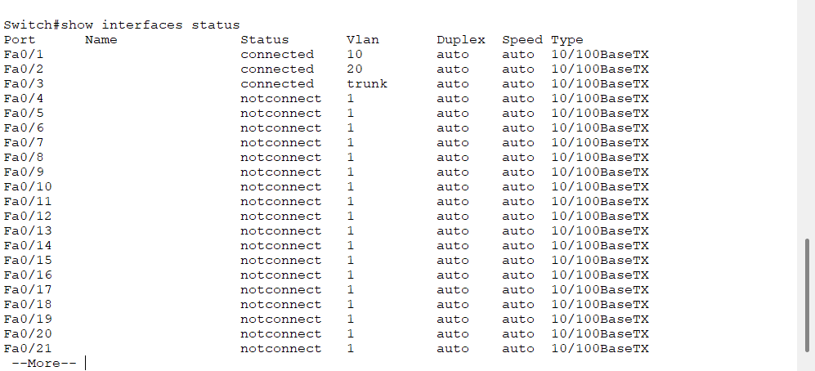

Show spanning-tree

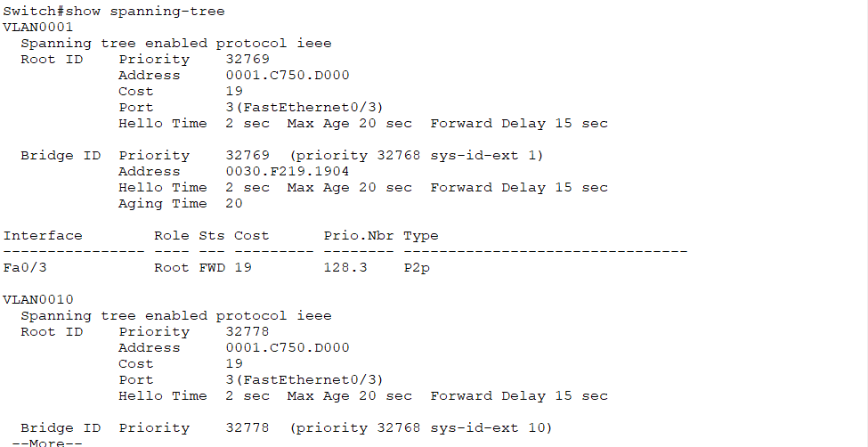

**Switch 1**

Show running-config

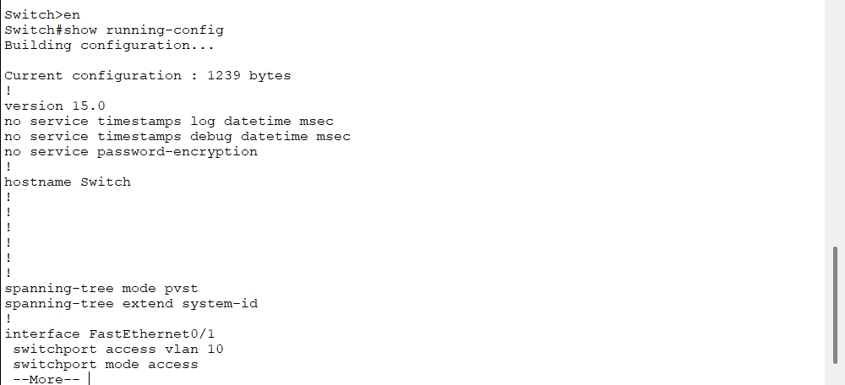

Show vlan brief

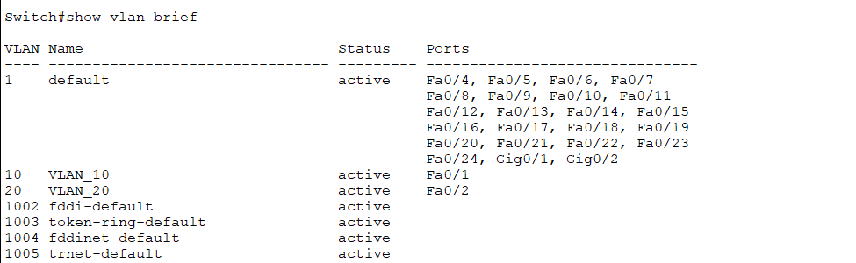

Show interfaces trunk

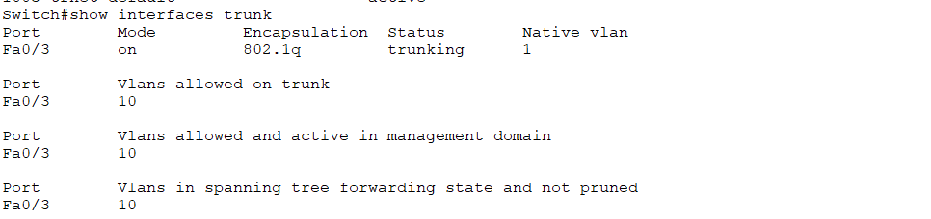

Show interfaces status

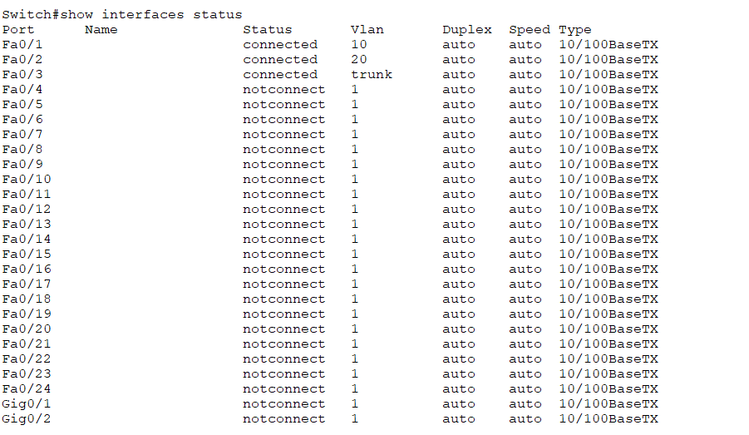

Show spanning-tree

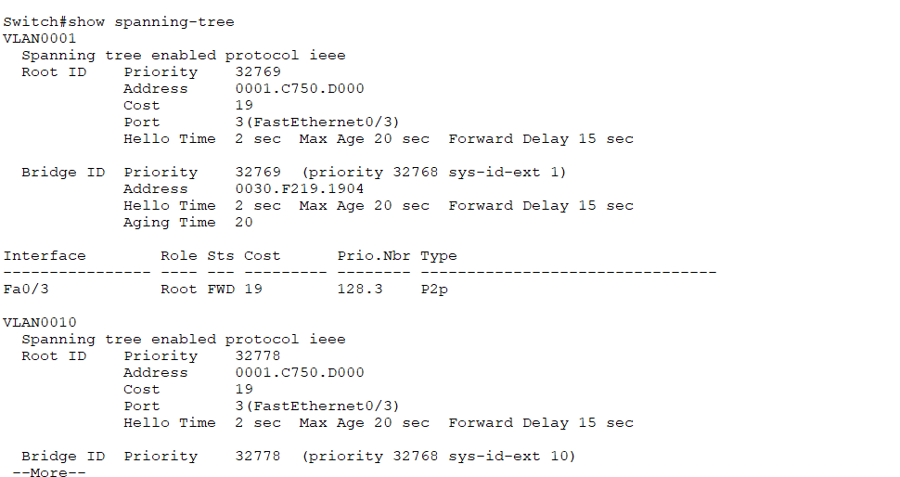

**Ping a Network Device**

**From pc 0**

To verify connectivity to a network device, use the ping command followed by the IP address of the target device. Below is an example of pinging the IP address 192.168.1.10

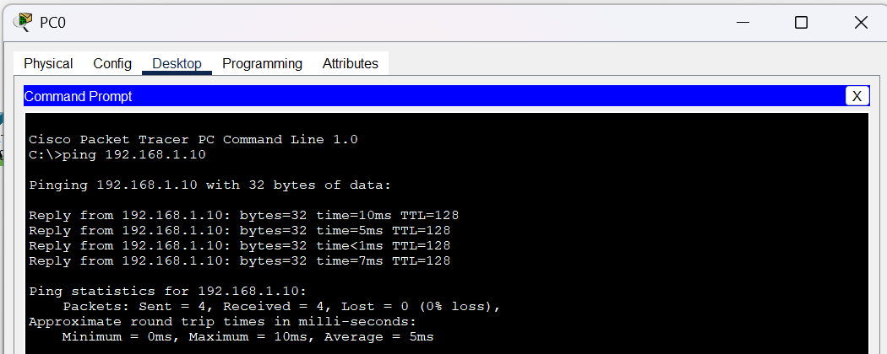

This step confirms that the device at 192.168.1.10 is reachable and provides details about the round-trip time for the packets.

To verify connectivity to a network device, use the ping command followed by the IP address of the target device. Below is an example of pinging the IP address 192.168.1.20

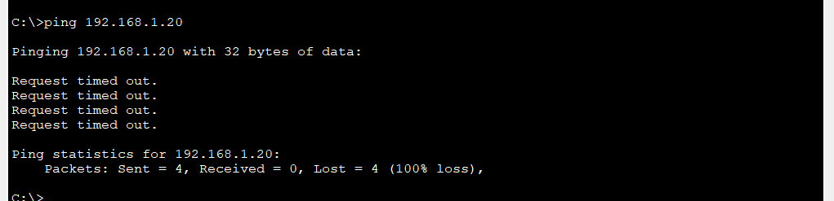

This step indicates that the device at 192.168.1.20 is unreachable, as all ping requests timed out.

**From pc 1**

To verify connectivity to a network device, use the ping command followed by the IP address of the target device. Below is an example of pinging the IP address 192.168.1.20 from PC1

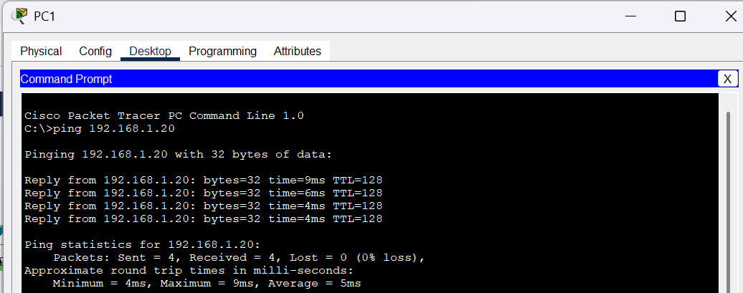

This step confirms that the device at 192.168.1.20 is reachable from PC1, with an average round-trip time of 5ms.

To verify connectivity to a network device, use the ping command followed by the IP address of the target device. Below is an example of pinging the IP address 192.168.1.10

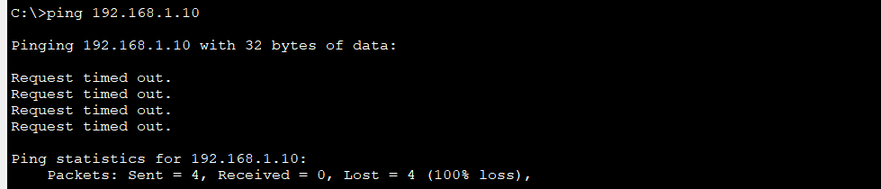

This step indicates that the device at 192.168.1.10 is unreachable, as all ping requests timed out.

**From pc 2**

To verify connectivity to a network device, use the ping command followed by the IP address of the target device. Below is an example of pinging the IP address 192.168.2.10

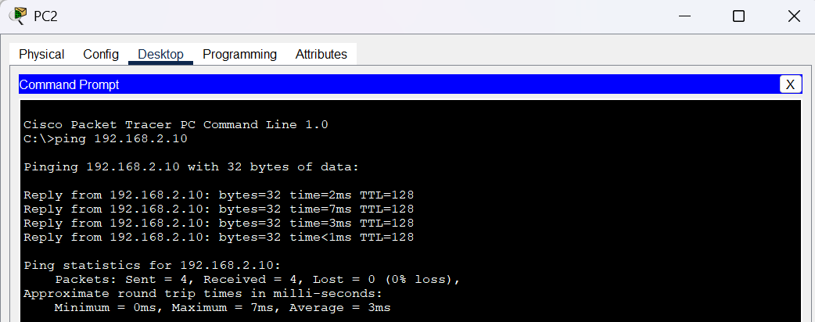

This step confirms that the device at 192.168.2.10 is reachable and provides details about the round-trip time for the packets.

To verify connectivity to a network device, use the ping command followed by the IP address of the target device. Below is an example of pinging the IP address 192.168.2.20

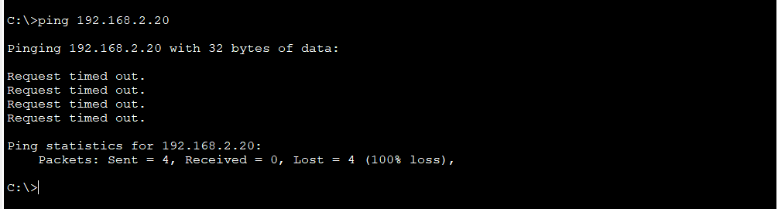

This step indicates that the device at 192.168.2.20 is unreachable, as all ping requests timed out.

**From pc 3**

To verify connectivity to a network device, use the ping command followed by the IP address of the target device. Below is an example of pinging the IP address 192.168.2.20

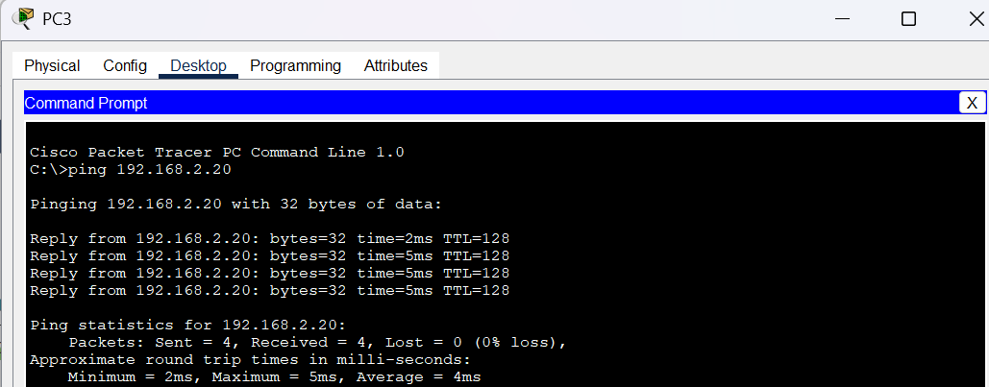

This step confirms that the device at 192.168.2.20 is reachable and provides details about the round-trip time for the packets.

To verify connectivity to a network device, use the ping command followed by the IP address of the target device. Below is an example of pinging the IP address 192.168.2.10

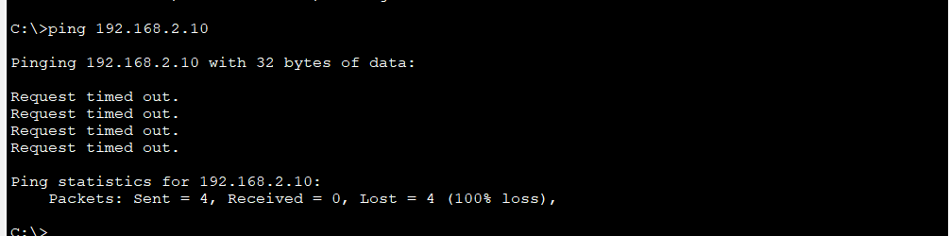

This step indicates that the device at 192.168.2.10 is unreachable, as all ping requests timed out.

**Trunking Configuration Between Two Switches**

